Design Document V1.0

Votary Softech Solutions Pvt. Ltd.
Plot No: 76, Lumbini layout,
Near Euro school,
Gachibowli-I (V), Hyderabad,
Telangana - 500032,
India.

Revision History
Version | Date of Revision | Description of Change | Reason for Change | Affected Sections | Approved By
0.1

Approval History
Version | Prepared By | Reviewed Date | Approved By/Date

Table of Contents

1. Overview
1.1 Block Diagram
1.2 Definitions and acronyms
1.3 Platforms and Tools
2. Design Approach
2.1 Gateway (Module 1)
2.2 Storage management (Module)
2.3 User Application
3.Module Design
2.1 Gateway(Rasperrypi)
2.2 Data Base
2.3 User Application
4.Files in Modules
4.1 Device management
4.2 Transporter & Storage Module
5. References

1.Overview
The overview of this project is to create IoT technology platform, to track and scan the BT/BLE tags, collect the information and store it on database.
Access the database through application as per the requirement.

1.1 Block Diagram:
GateWay

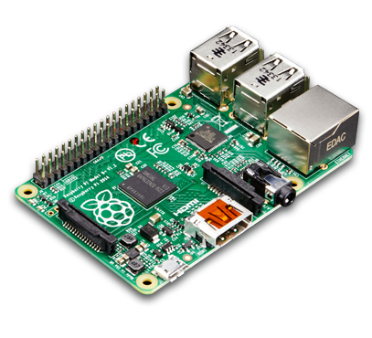


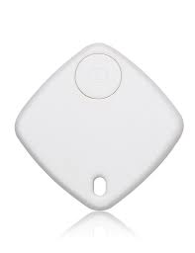
Ble/BT Tags


Remote Database


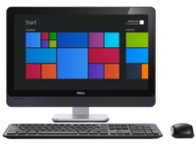

User Application

1.2 Definitions and Acronyms:
The terms in use in the document are explained below
Acronym | Description
VITA | Votary Tech IOT Architecture

1.3Platform and Tools (Later we add)

2.Design Approach/ System Overview

The different modules used in this system are Gateway and Stoarage and User Application.

2.1 Module 1: Gateway (DM)

The Gateway Module – Provides the capability to scan continuously for nearby BLE/BT devices and publishes data to storage module

2.2 Module 2: Storage
Storage Module – Stores the received BLE/BT data in a specific format and provides access to application to query the required data.
2.3 Module 3: Application
Application Module – It provides as interface where end user can query required data i.e locate, in/out time.

Deliverables:

Digital Campus Gateway

SQL Database

User Application (Desktop/Mobile)

BLE Stack:

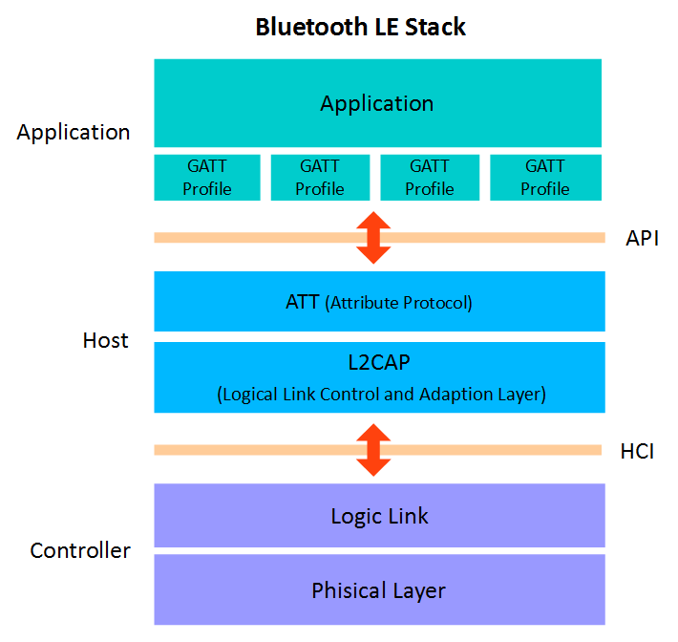

Sequence Diagram
Sensor to Gateway
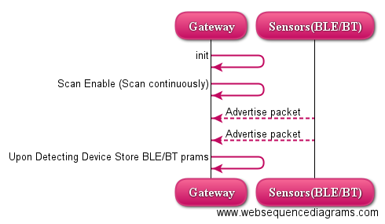

-> Gateway should capture BLE/BT params i.e macID, DeviceType, Rssi, TimeStamp

Gateway to DB to User Application
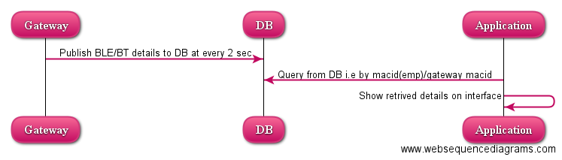

-> Gateway should publish BLE/BT params to DB i.e BLE/BT macID, DeviceType, Rssi, TimeStamp,GatewaymacID

Gate way -API’s
--> void Initialization(int *dev_id,int *sock)
int hci_get_route(bdaddr_t * addr)------it searches for local bluetooth adapter,and returns the device id of the given bdaddr_t, you can pass NULL so it returns the first available device.
If you know the device's address you want to use you can pass it to this function
int hci_open_dev(int adapter_id)
)-----using this you can open resources to use the device you choose
-->inquiry_info * BT_Scan(int adapter_id,int len,int *num_rsp)
int hci_inquiry(int adapter_id, int len, int max_rsp, const uint8_t * lap , inquiry_info ** devs , long flags)--------sends an inquiry signal to receive information about the devices to respond
- adapter_id = the adapter you choose before
- len = inquiry time, the standard is about 8 * 1.24 (so len = 8)
- max_rsp = maximum devices response (usually 255)
- flags = usually IREQ CACHE FLUSH, if you pass 0 then previous inquiry info may be returned
- lap = determine the type of inquiry, if you don't care give it NULL.
- devs=is structure which stores the scanned device info

-->Process_BT_data(int num_rsp,inquiry_info *scanned_info_ptr,int sock)
ba2str---------convert bdaddr to a string
int hci_read_remote_name(int sock, const bdaddr_t *bdaddr, int len, char *name, int time_out)-----gives devices friendly name
-->int8_t Read_rssi(int sock)
hci_read_rssi(int sock, uint16_t handle, int8_t *rssi, int time_out)----------reads the signal strength of founded device
-->BT_abort
bt_abort------abort the scanning

-->DB_Connect
mysql_init-----allocates or initialises a MYSQL object suitable for mysql_real_connect() function.
mysql_real_connect-----establishes a connection to the database
mysql_query------mysql_query() function call to both create a table and insert data into it.
finish_with_error--------to avoid unnecessary repetition, we create a custom finish_with_error() function

Table Format
BLE/BT Details
BLE/BT macID | DeviceType | Rssi | TimeStamp | GatewaymacID

Employee Name Dump Data Table
Employee Name | BLE/BT macID

Gateway Name Dump Data Table
Gateway Name | Gateway macID

